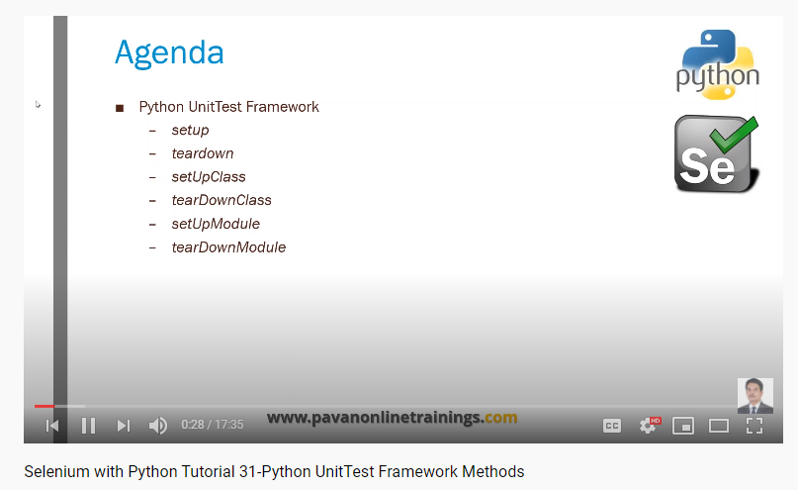

Set up method will execute before every time real test method executes

Teardown method will execute after every time real test method executes

Set up class method will execute once before test method executes

Teardown class method will execute once after real test method executes

Set up module will execute once before executing any class, method in test class

Tear down module will execute once after executing completing everthing in python module